# MatchPlay

Team Number 1

Team Name: Strokrs

## Team Members:

* Nhat Nguyen - GIT: sv223229
* Shaun Kittrell - GIT: shauncert
* Ainsley Fletcher - GIT: ainsfletcher
* Adam Carlson - GIT: adamcarlson1 - adca6295@colorado.edu
* Moses Bazzi - GIT: mosesbazzi
* Matt Lattin - GIT: mattlattin

## Repository Link:

* <https://github.com/ainsfletcher/CSCI3308-Spring2023-Strokr-016-Group1>

## Application Description:

* Here we are designing a Tinder-esque application with the purpose of bringing golfers together. Within the profile, users will be able to add relevant data such as skill level, golfing preferences and most importantly location. Based upon location, users will be able to match with people within their vicinity and communicate from there. Moreover, within the application, users will be able to view weather forecasts based upon the days they want to go with partners they matched with.
* Profile Requirements;
  + Handicap
  + Booze level
  + Location
  + Walk or cart
  + Pictures
  + Morning or afternoon tee times
  + Home course
  + Age
  + Bio

## Vision statement:

* For golf lovers that want to meet up with other local golfers. MatchPlay is a matching platform that will link players based on personal interest and skill level in Colorado.

## Communication Plan:

* The primary form of communication will be through text and discord.

## Meeting Plan:

* TA Meeting: Thursday at 1pm <https://cuboulder.zoom.us/j/6808546254#success>
* Team Meeting: Thursday at 12pm

## Use Case Diagram:

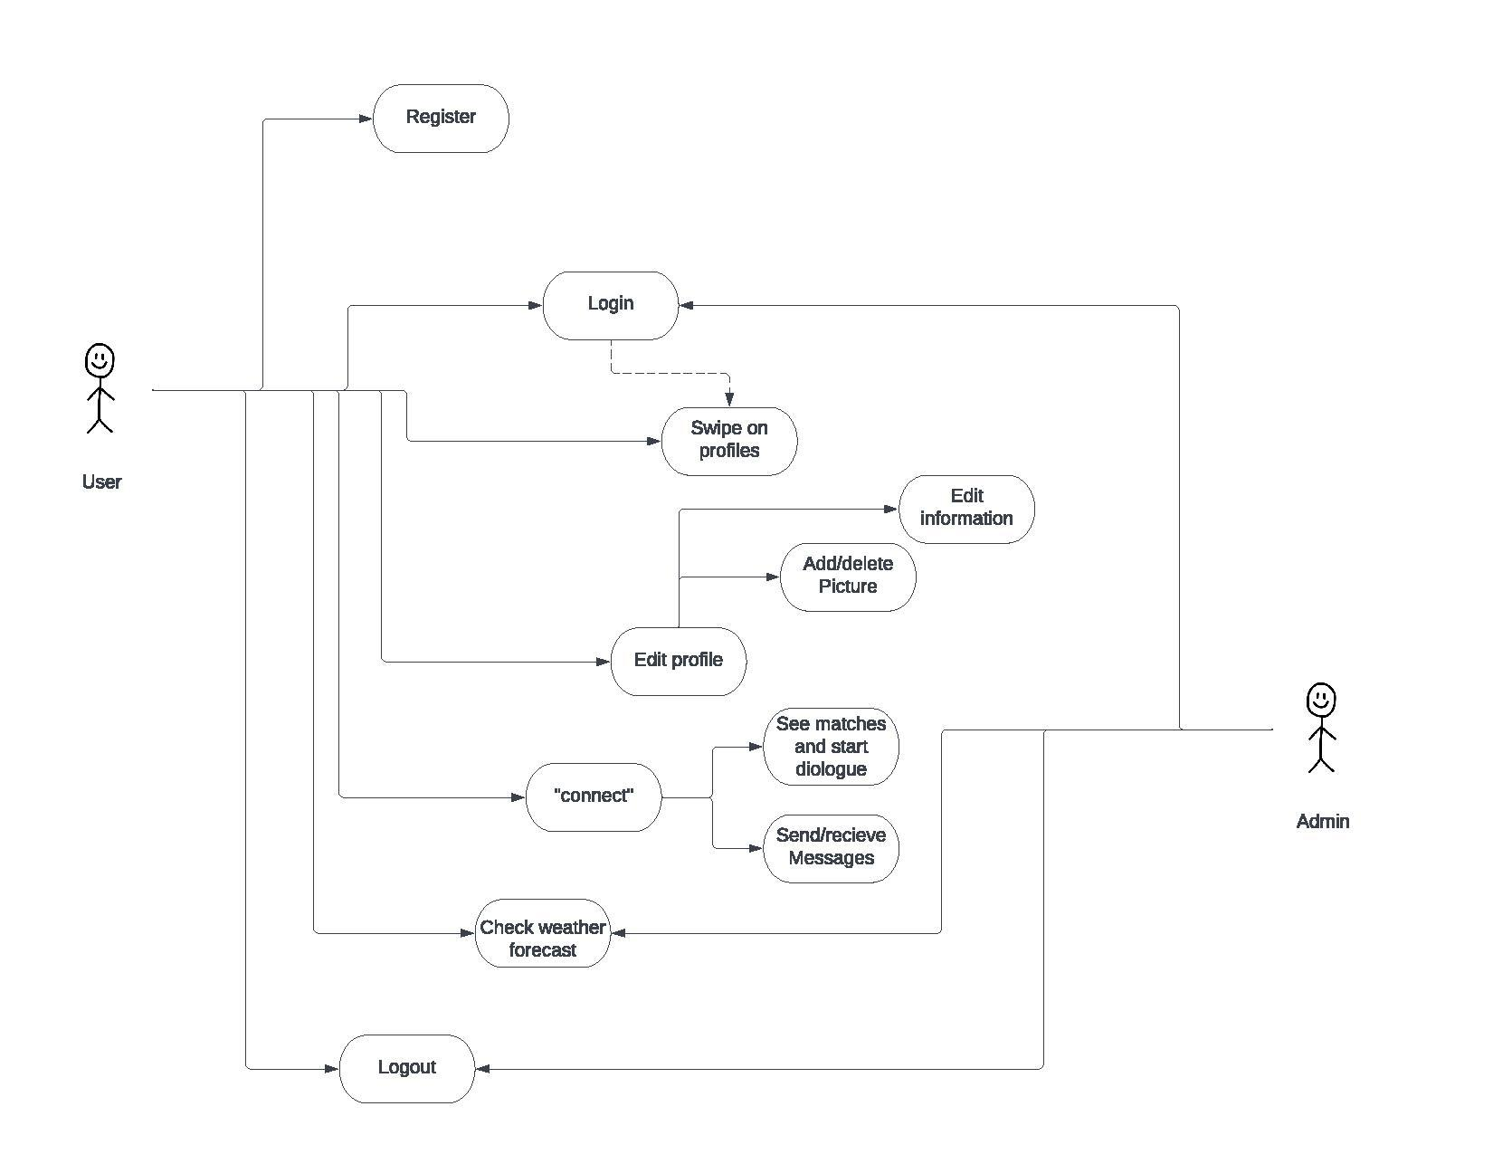

## Wireframe:

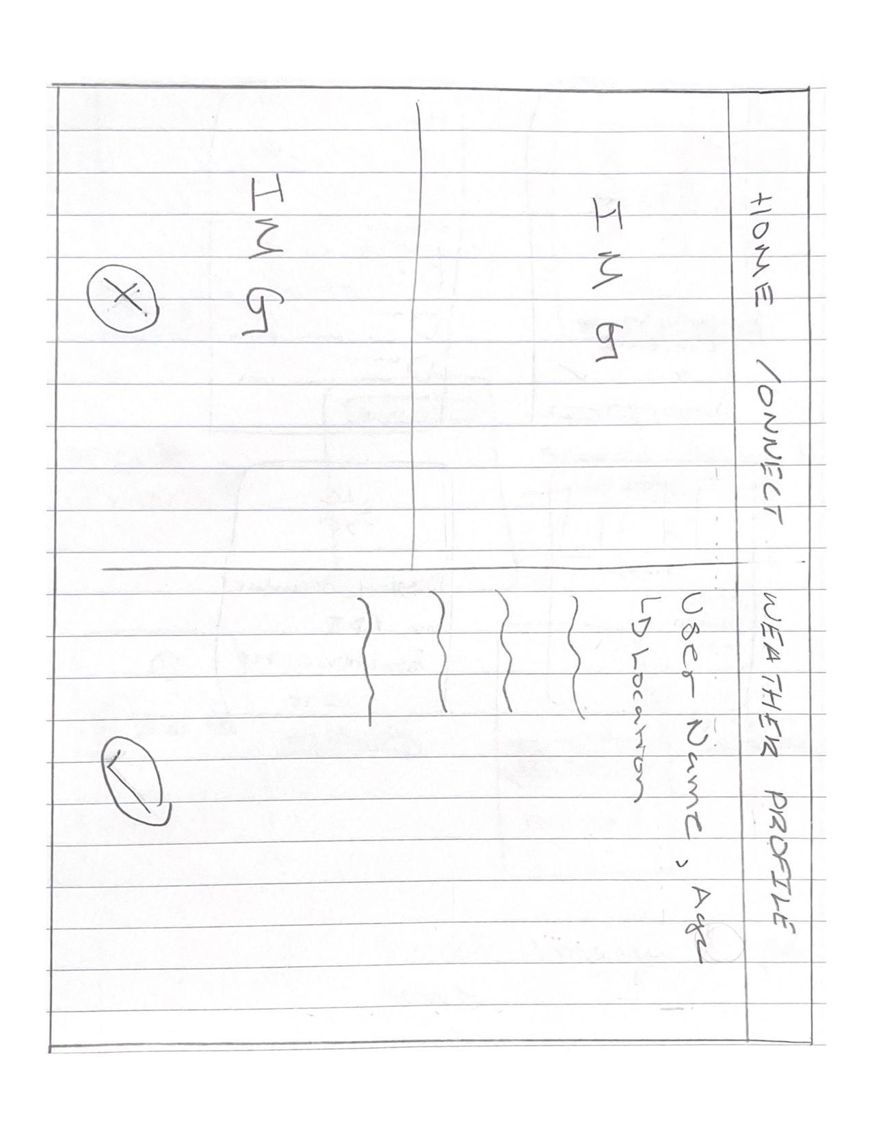

## API Possibilities:

* Golf course API: <https://golf-course-database.com/api-v1-0/> (not free)
* Weather API:<https://dev.qweather.com/en/> (free)
* Golfbert API: <https://golfbert.com/>
* Email Verification API: <https://eva.pingutil.com/>